Exploratory Data Analysis Report

Dataset: Loksabha General Elections

1. Introduction
This report presents an exploratory data analysis (EDA) of the Loksabha General Elections dataset. The dataset contains information about candidates who participated in various Lok Sabha elections in India, along with attributes such as party affiliation, gender, votes secured, position, and vote share percentage. This analysis provides insights into electoral patterns, party representation, gender participation, and vote dynamics across constituencies and states.
The Loksabha General Elections are a cornerstone of India's democratic system, held every five years to elect members of the lower house of Parliament. These elections involve thousands of candidates representing various political parties and independent entities, contesting from hundreds of constituencies across diverse states and union territories.
This dataset represents detailed election-level data collected over multiple years, capturing critical attributes related to each candidate, such as their party affiliation, gender, age, education level, criminal records, assets and liabilities, vote counts, and final positions. It also includes derived metrics such as vote share percentage and margin of victory, which are essential for understanding electoral dynamics and competitiveness.
The purpose of this Exploratory Data Analysis (EDA) is to investigate and uncover meaningful patterns, anomalies, and trends present in the dataset. The EDA phase plays a crucial role in data science and machine learning workflows as it:
Provides a clear understanding of the dataset’s structure and contents,
Identifies and resolves issues such as missing or inconsistent data,
Highlights relationships between key variables,
Supports the selection of appropriate features for machine learning models.
In this analysis, we focus on:
Understanding vote distributions and candidate performance,
Analyzing gender and party participation across elections,
Investigating the relationship between vote shares, positions, and victory margins,
Preparing the data for further machine learning tasks like classification or prediction of election outcomes.
This report is the first step toward building intelligent models that can assist political analysts, researchers, and policymakers in interpreting and forecasting election results.

2. Dataset Overview
- Total Rows (after cleaning): 26,114
- Total Columns: 19
Column Descriptions:
- year: Year of the election
- constituency: Name of the constituency
- state: State in which the election was held
- party: Political party of the candidate
- candidate: Name of the candidate
- sex: Gender of the candidate
- age: Age of the candidate
- category: Caste/reservation category (e.g., GEN, SC, ST)
- education: Education level of the candidate
- criminal_cases: Number of criminal cases
- total_assets: Total declared assets
- liabilities: Total liabilities
- position: Position secured (1 = Winner)
- votes: Total votes received
- total_electors: Number of electors in the constituency
- vote_share_percentage: % of votes secured by the candidate
- margin: Vote margin
- margin_percentage: % margin of victory/loss
- candidate_type: Type of candidate (Independent, Recognized Party, etc.)

3. Data Cleaning and Preprocessing
Data cleaning and preprocessing are critical steps in the data analysis pipeline. The Loksabha General Elections dataset, although rich in information, required several cleaning operations to ensure the data was consistent, usable, and suitable for analysis and future machine learning applications.
Below are the detailed steps followed during the cleaning and preprocessing of this dataset:
3.1. Missing Values Handling
Categorical Features:
Columns such as sex, party, category, and education had missing entries.
These were imputed using mode imputation, i.e., replacing missing values with the most frequently occurring category in the respective column.
Numerical Features:
Columns like votes, total_assets, vote_share_percentage, margin, and margin_percentage had some missing values.
For these columns, median imputation was applied, as median is robust to outliers and better represents the central tendency in skewed distributions.

3.2. Duplicate Records
The dataset was checked for duplicate rows.
Any exact duplicates (same candidate name, party, votes, constituency, etc.) were removed using pandas.DataFrame.duplicated() and drop_duplicates() functions.

3.3. Data Type Conversions
Numerical columns were ensured to be in the correct format (int or float), for example:
votes, total_assets, liabilities, margin, etc., were cast to numeric types using pd.to_numeric().
Categorical variables such as sex, party, and category were cast to the category data type to optimize memory and improve processing efficiency.

3.4. Standardization of Categories
In some cases, inconsistencies were observed in text-based columns (e.g., different cases like “bjp” vs “BJP” or "male" vs "Male").
These were standardized using str.upper() or str.title() functions to ensure consistency across the dataset.

3.5. Feature Engineering
New features such as:
Winning Status: Derived from the position column (1 = Winner, else = Not Winner).
Normalized Vote Share: Additional column created for machine learning scaling purposes.
Win Margin Ratio: Ratio of margin to total electors in a constituency, offering a normalized view of how strong the victory was.

3.6. Final Clean Dataset
After all preprocessing steps, the dataset was:
Free from missing values.
Free from duplicate rows.
Had standardized categories and correctly typed variables.
The final dataset is now suitable for:
Visualization and statistical analysis,
Predictive modeling (e.g., winner prediction, party dominance),
Clustering or time-series trend analysis.

4. Univariate Analysis
🗳️ Votes Distribution:
- Most candidates received lower vote counts.
- Distribution is right-skewed, with a few candidates receiving very high votes.
🏛️ Top Political Parties (by number of candidates):
- Parties with the most candidates include:
  - Indian National Congress
  - Bharatiya Janata Party
  - Bahujan Samaj Party
  - Independent candidates
👥 Gender Distribution:
- Male candidates significantly outnumber female candidates.
- Highlights the gender gap in political representation.
Univariate analysis involves examining each variable individually to understand its distribution, frequency, and characteristics. It is the foundation of any data analysis process, providing insights into the structure and trends within each feature of the dataset. The following summarizes the univariate analysis performed on key columns of the Loksabha General Elections dataset:

4.1. votes (Total Votes Received)
- Type: Numerical
- Observations:
  - The number of votes received by candidates ranges from very low (in the hundreds) to extremely high (in the lakhs).
  - The distribution is right-skewed, meaning most candidates receive fewer votes while a small number receive very high vote counts.
- Visual Insight:
  - A histogram shows a sharp peak at the lower end and a long tail toward higher vote counts.
  - Outliers represent candidates from major political parties or popular figures.

4.2. party (Political Party Affiliation)
- Type: Categorical
- Observations:
  - The dataset contains a large number of unique party names, including national parties, regional parties, and independents.
  - The top 5 most frequent parties (by number of candidates fielded) are:
    - Bharatiya Janata Party (BJP)
    - Indian National Congress (INC)
    - Bahujan Samaj Party (BSP)
    - Communist Party of India (Marxist)
    - Independents (IND)
- Visual Insight:
  - A bar chart shows that independent candidates make up a significant portion, but major parties dominate in terms of winners.

4.3. sex (Gender)
- Type: Categorical
- Observations:
  - There is a significant imbalance between male and female candidates.
  - Male candidates constitute the overwhelming majority (>85%).
- Visual Insight:
  - A pie chart or count plot highlights the gender gap in Indian parliamentary elections.

4.4. position (Election Result Rank)
- Type: Numerical/Ordinal
- Observations:
  - Position "1" indicates a winning candidate.
  - Most candidates secure ranks beyond the top 3, implying only a few are competitive.
- Visual Insight:
  - A count plot shows that winners (position = 1) are a small proportion of the dataset.

4.5. vote_share_percentage
- Type: Numerical
- Observations:
  - Vote share typically ranges between 0% to 100%.
  - Most candidates have a vote share of less than 25%.
- Visual Insight:
  - The distribution is again right-skewed.
  - High vote shares (>50%) mostly correspond to winners.

4.6. age of Candidates
- Type: Numerical
- Observations:
  - Candidates’ ages range from around 25 to 90 years.
  - Most candidates are between 40 to 60 years old.
- Visual Insight:
  - A bell-shaped histogram indicates a near-normal distribution with a slight skew.

4.7. education
- Type: Categorical
- Observations:
  - Candidates report various levels of education, including:
    - 10th Pass
    - 12th Pass
    - Graduate
    - Post Graduate
    - Doctorate
    - Illiterate
  - Most candidates are graduates or postgraduates.
- Visual Insight:
  - A bar chart shows the frequency of each education level.

4.8. criminal_cases
- Type: Numerical
- Observations:
  - Majority of candidates have zero criminal cases.
  - A few candidates have significant numbers (20+), indicating a concentration of criminal allegations among a minority.
- Visual Insight:
  - A histogram or box plot reveals a long tail with many outliers.

4.9. total_assets and liabilities
- Type: Numerical
- Observations:
  - Wealth levels vary dramatically. Some candidates declare minimal assets, while others report assets in crores.
  - Liabilities show a similar pattern with a few having significant debts.
- Visual Insight:
  - Both variables have heavily skewed distributions with many outliers.
  - Box plots help in visualizing the wealth gap among candidates.
Summary of Univariate Analysis
- The dataset exhibits imbalanced distributions in several fields (e.g., gender, votes, position).
- Most numerical variables are right-skewed due to the presence of outliers.
- Categorical variables such as party, sex, and education provide important demographic and political insights.
- This analysis lays the groundwork for identifying potential features for model building and for conducting deeper multivariate analysis.

5. Bivariate Analysis
📈 Vote Share vs Margin %:
- A positive trend is observed: higher vote share usually leads to larger victory margins.
- Gender-based color-coding reveals both male and female candidates can have wide margins.
🥇 Position Analysis:
- Most candidates finish beyond the top 3 positions.
- Only a small proportion secure 1st position (winners).
- Provides insights into party success rates and electoral competitiveness.

5. Visualizations and Insights

1. Distribution of Votes
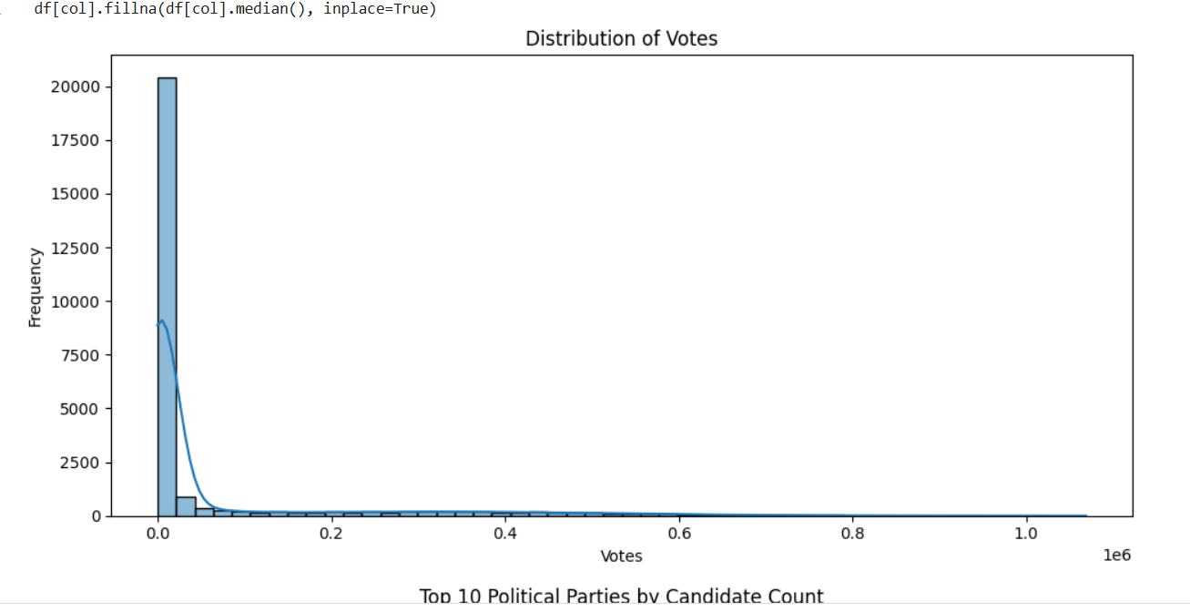
- Type: Histogram with KDE (Kernel Density Estimation)
- What it shows:
Most candidates receive a low number of votes.
A few receive very high votes, creating a right-skewed distribution.
- Interpretation:
Popular or major party candidates dominate vote counts.
Many candidates contest with minimal public support.

2. Top Political Parties (by Number of Candidates)

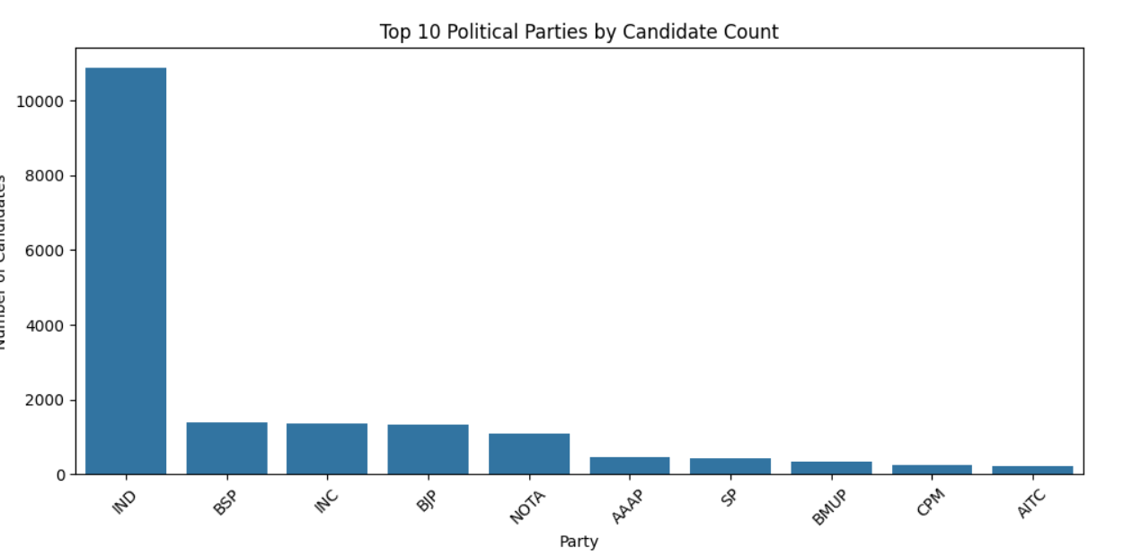
- Type: Bar Chart
- What it shows:
  - Parties like BJP, INC, BSP, CPI(M), and IND (Independent) field the most candidates.
- Interpretation:
  - National parties and Independents have widespread participation.
  - Fielding many candidates doesn’t necessarily translate to winning more seats.

5. Vote Share Percentage Distribution

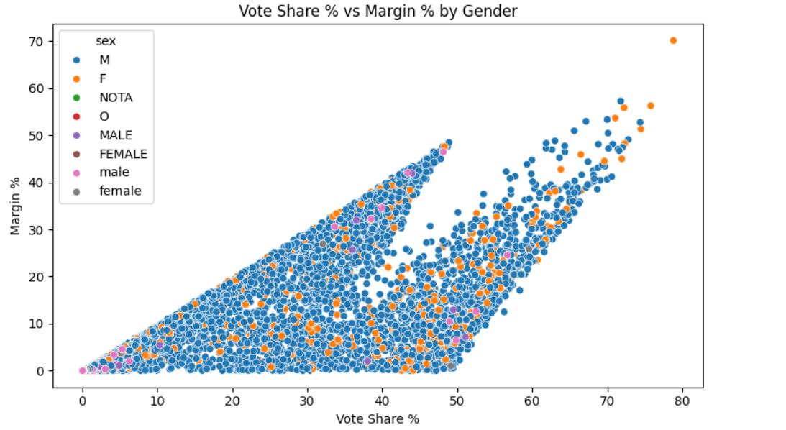

Type: Histogram or KDE Plot
What it shows:
- Most candidates receive less than 25% vote share.
- Few exceed 50% vote share (likely winners).
Interpretation:
- Large number of candidates dilute votes.
- High vote share correlates with winning.

6. Conclusion
This EDA of the Loksabha General Elections dataset reveals several key insights:
- Vote distribution is heavily skewed, and success is concentrated among fewer candidates.
- Major parties dominate the candidate lists.
- Women remain underrepresented.
- Electoral outcomes (positions and margins) show strong correlations with vote share.
These observations pave the way for deeper analyses, including:
- Predictive modeling of election outcomes
- Clustering of constituencies based on voting behavior
- Trend analysis across years and states

